

Project Name: ServiceSathi.pk
Course: Fundamentals of Software Engineering
Deliverable: Final Report

Group Members:
Syeda Faryal Zehra (24L-2556)
Ibrahim Qaiser (24L-2513)
Syeda Ume Abeeha Naqvi (24L-2528)

Class: BDS-4B
Submission Date: 3rd-May-2026

Service Sathi
ServiceSathi.pk is an online service marketplace that connects customers with service providers such as plumbers, cleaners, cooks, and electricians throughout Lahore.
The system includes three main actors: users, sellers, and administrators. Users can browse and book services, sellers can list their services, and administrators manage platform activity. The system is implemented using Flask(python), HTML/CSS, and a SQL database.

User Stories
Sprint 1
Module Name: User and Service Management Module
Description: The User and Service Management Module handles the core functionality of the ServiceSathi platform. It allows users and sellers to register and log in to the system. Sellers can add services that are displayed to users. Administrators can access the admin panel to monitor users, sellers, and services. This module establishes the main interaction between users, sellers, and the system.The following features are a part of the sprint 1 of this project.

Sprint Backlog
Tasks | Description
Registration | Allows users and sellers to create accounts
Login System | Authenticates seller and user
Admin Login | Admin access panel
Add Service | Allowing seller to add a service
Service Listing | List of all the services
Seller/User Dashboard | Seller and users profile display
Admin Dashboard | Admin view page
Database Connection | Connect Flask with SQL

Sprint 2:
Module Name: Booking, Status Management, and Admin Expansion Module
Description: Building upon the User and Service Management module from Sprint 1, Sprint 2 introduces the core transactional capabilities of the platform. Users can now book specific services and provide exact job addresses and instructions. Sellers are empowered to manage these requests by accepting or rejecting them. We also introduced dynamic UI elements for better data viewing, robust time-based constraints for booking cancellations, and administrative controls to dynamically expand platform categories.

Sprint Backlog
Tasks | Description
Service Booking | Allows users to book a service with date, time, address, and instructions.
Accept/Reject Booking | Allows sellers to accept or reject incoming booking requests.
Notifications | The user will receive notifications of the booking status from seller and vice versa
Cancel Booking | Allows users to cancel pending/accepted bookings with a 30-minute lockout.
Search seller and filter | Allows the user to search seller and apply price filters
Admin Management | Allows admins to create new service categories dynamically and remove sellers.

Sprint 3:
Module Name: Booking & Account Management Module
Description: Building upon the transactional and booking management capabilities introduced in Sprint 2, Sprint 3 focuses on enhancing user engagement, system interactivity, and service transparency. This iteration enables users and sellers to manage their profiles, receive real-time notifications, and build trust through reviews and ratings. Payment and booking statuses are now tracked dynamically, improving system clarity and user experience. Additionally, an intelligent Sathi Bot has been introduced to assist users with queries and navigation, making the platform more interactive and user-friendly.

Sprint Backlog
Tasks | Description
Profile Editing | Allows users and sellers to update their personal information, contact details, and profile settings.
Reviews | Allows users to rate and review services after booking completion to ensure transparency and quality.
Notifications | The user will receive notifications of the booking status from seller and vice versa
Payment status | Displays and tracks whether a booking has been paid or is pending.
Booking status update | Allows sellers (and system/admin) to update booking status such as accepted, rejected, or completed.
Sathi Bot | Provides an interactive chatbot to assist users with queries, navigation, and platform guidance.

Design
1.Use case
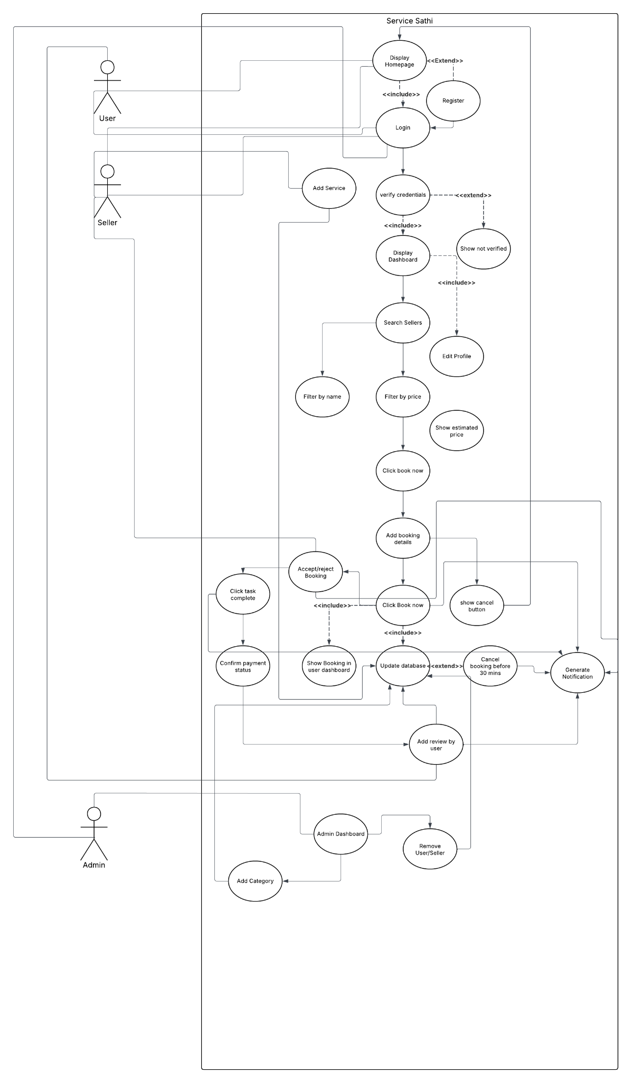
2. Class Diagram
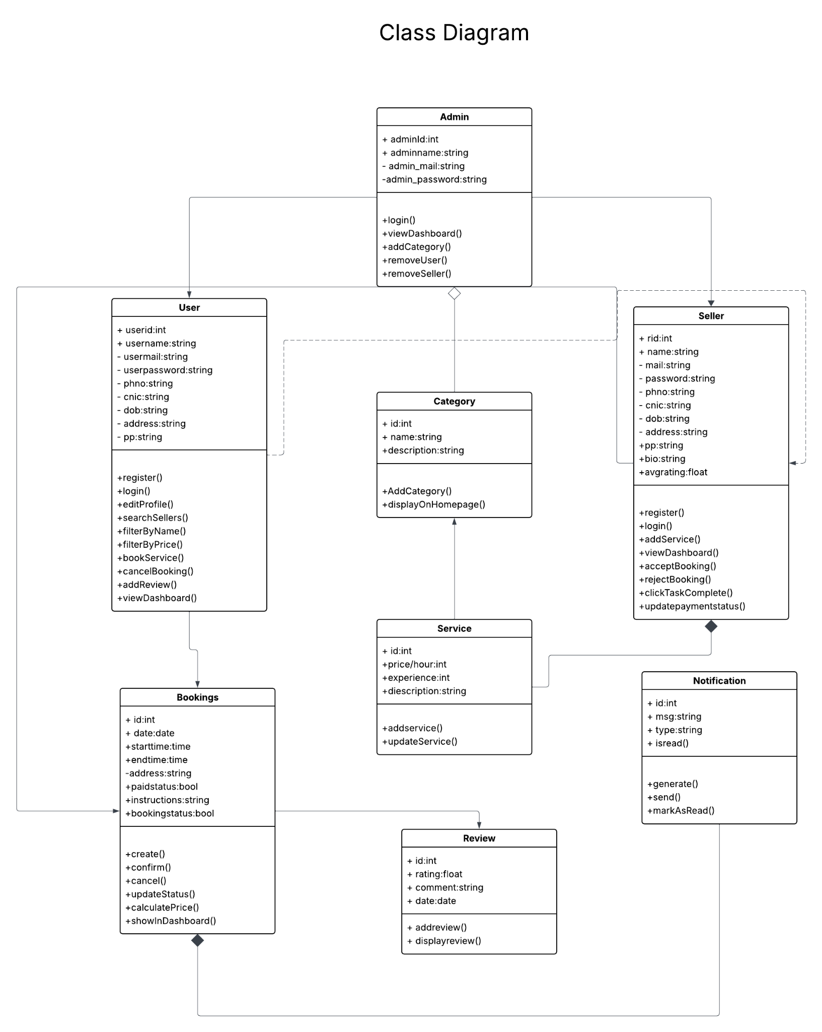

3. Activity Diagram

Accept reject booking
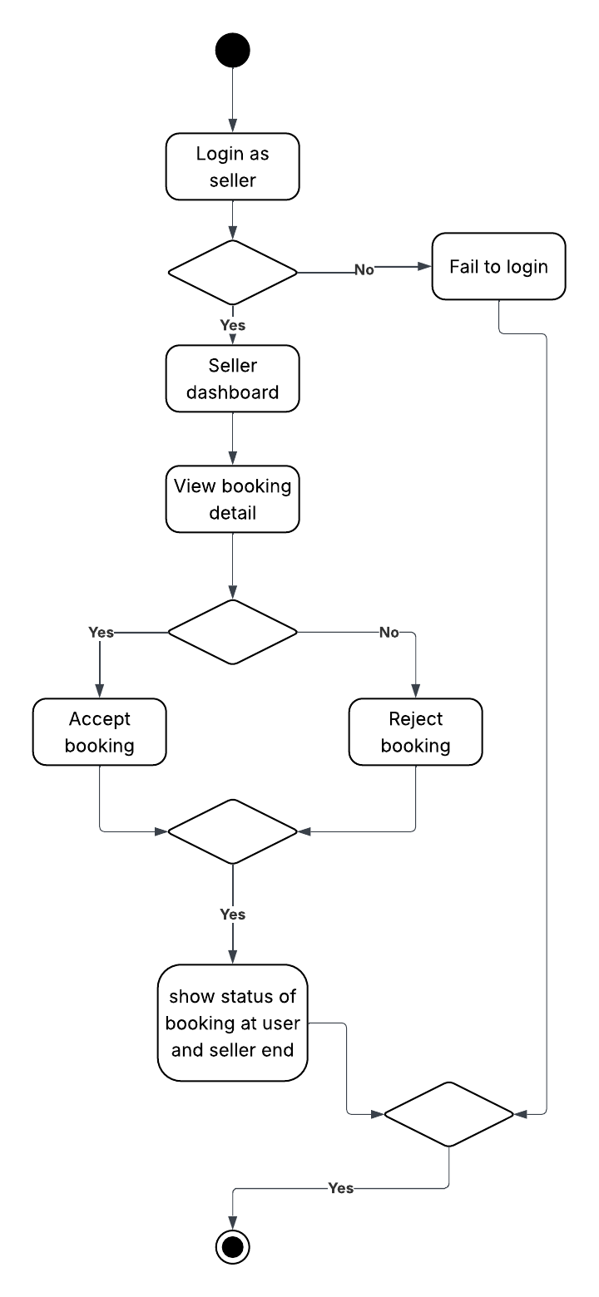
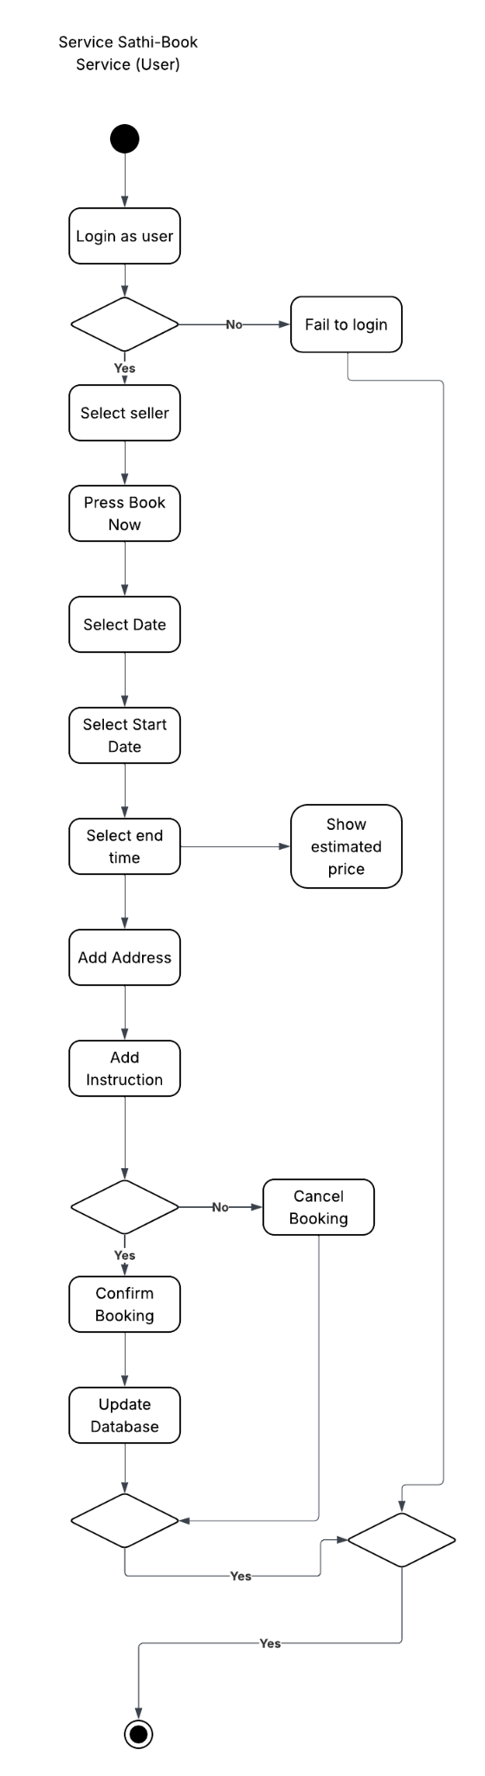
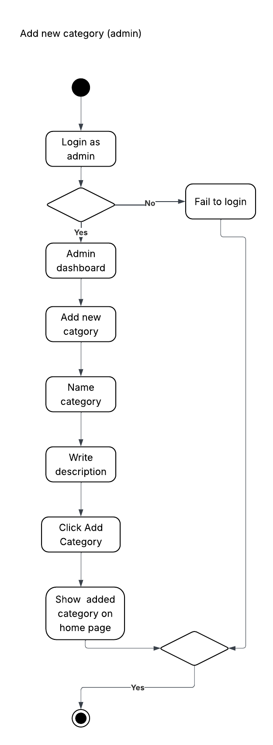
4.Sequence diagram
1.Book a service
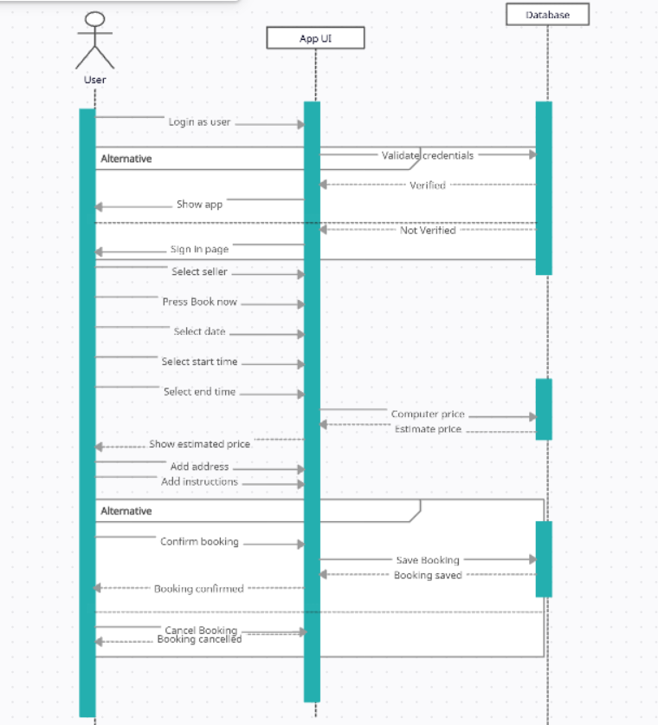
2.Accept/ reject booking
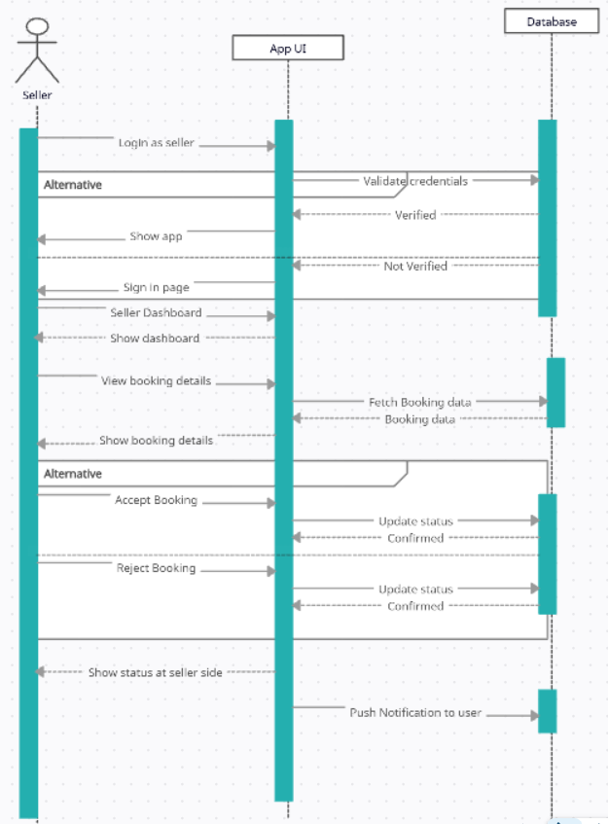
3 Add Category
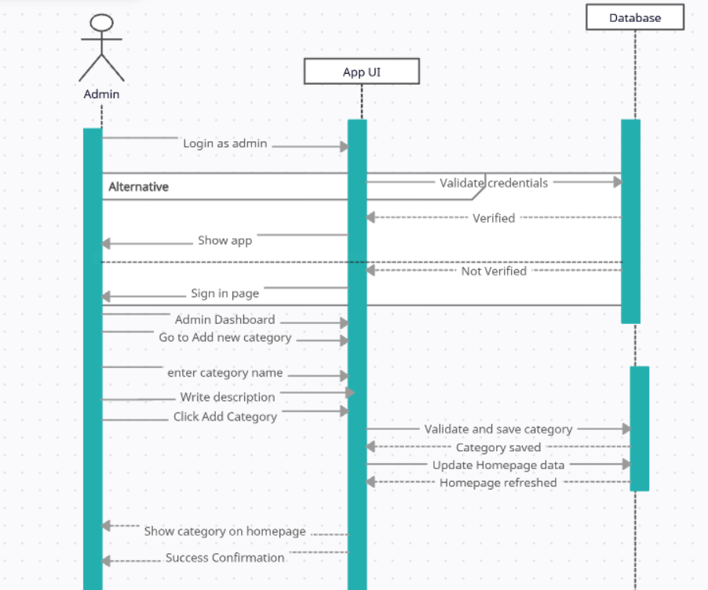

Project Burn Down Chart

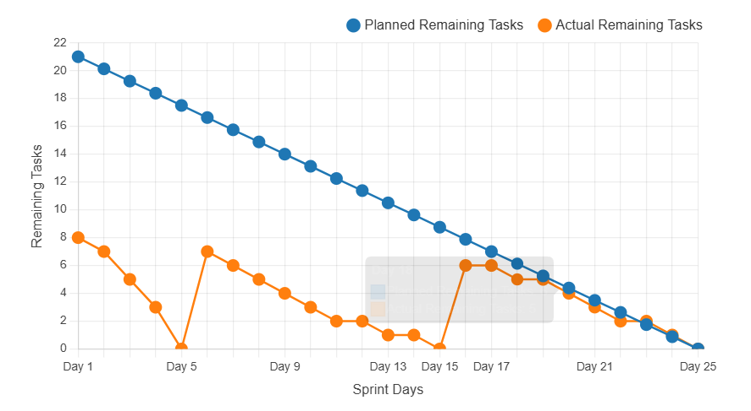

Architecture Diagram: Client server architecture

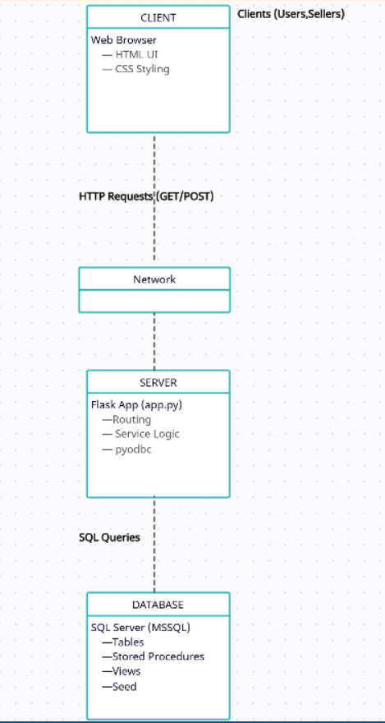
Boundary Value Analysis

- Password

Case | Input | Expected
Below Min | 7 chars | Reject
Min | 8 chars | Accept
Just Above Min | 9 chars | Accept
Normal | 12 chars | Accept
Just Below Max | 254 chars | Accept
Max | 255 chars | Accept

- Email

Case | Input | Expected
Below Min | a@b.c | Reject
Min | a@bc.de | Accept
Just Above Min | ab@cd.ef | Accept
Normal | user@gmail.com | Accept
Just Below Max | 99 chars | Accept
Max | 100 chars | Accept

- Phone number

Case | Input | Expected
Below Min | 10 digits | Reject
Min | 11 digits | Accept
Just Above Min | 12 digits | Reject
Normal | 11 digits | Accept
Just Below Max | 10 digits | Reject
Max | 11 digits | Accept

- CNIC

Case | Input | Expected
Below Min | 12 digits | Reject
Min | 13 digits | Accept
Just Above Min | 14 digits | Reject
Normal | 13 digits | Accept
Just Below Max | 12 digits | Reject
Max | 13 digits | Accept

- Age

Case | Input | Expected
Below Min | 7 | Reject
Min | 18 | Accept
Just Above Min | 19 | Accept
Normal | 25 | Accept
Just Below Max | 60 | Accept
Max | 100+ | Accept

- Username

Case | Input | Expected
Below Min | (empty) | Reject
Min | 1 char | Accept
Just Above Min | 2 char | Accept
Normal | abc123 | Accept
Just Below Max | 49 char | Accept
Max | 50 char | Accept

- Name

Case | Input | Expected
Below Min | (empty) | Reject
Min | 1 char | Accept
Just Above Min | 2 chars | Accept
Normal | Faiqa Sadaf | Accept
Just Below Max | 99 char | Accept
Max | 100 char | Accept

Scrum Board

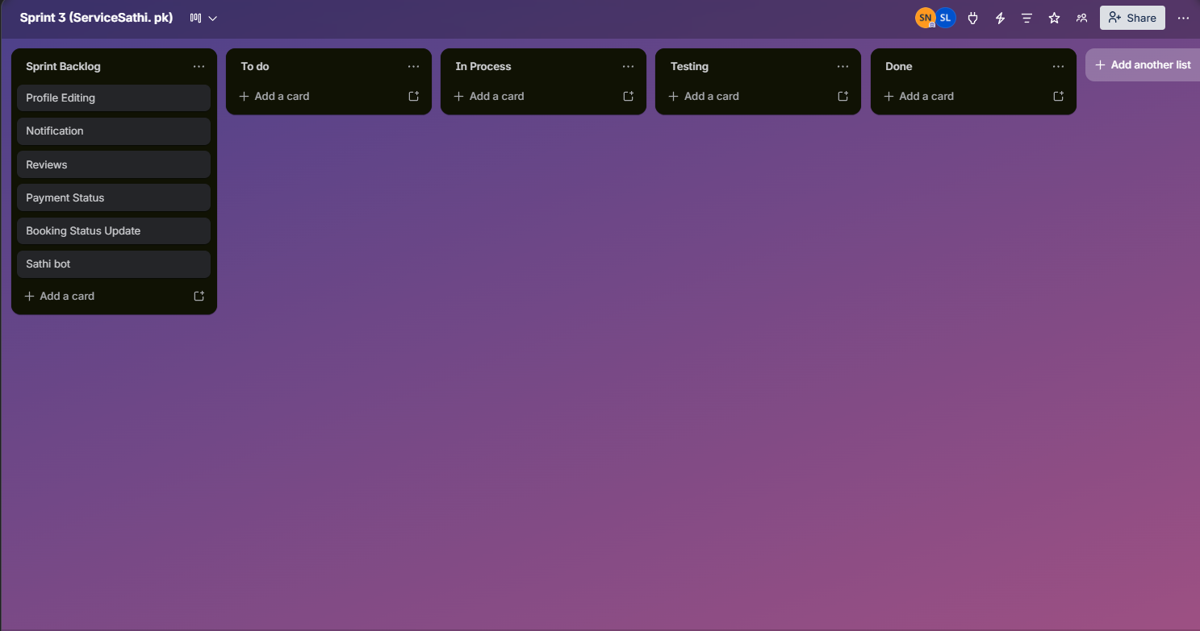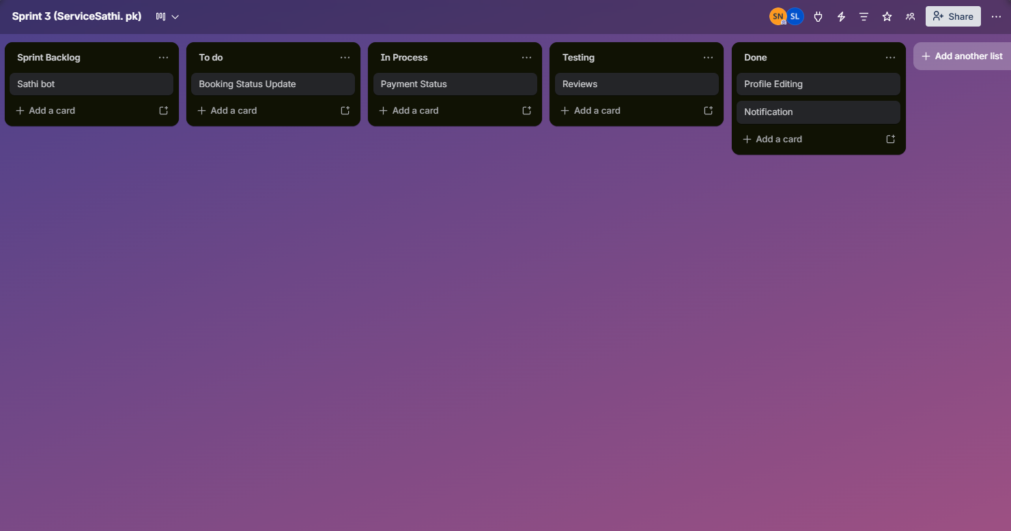
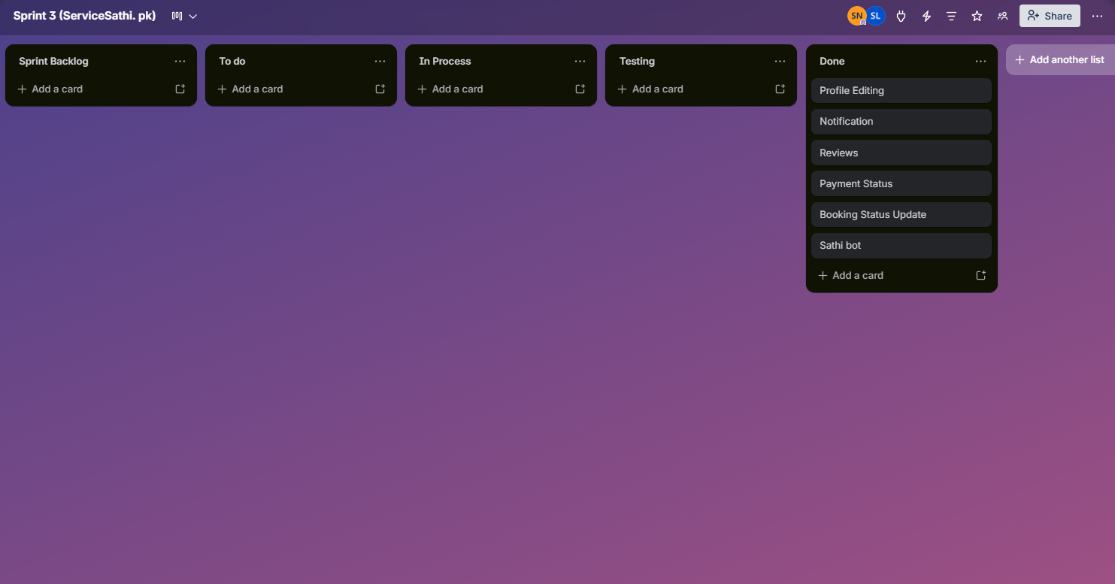

Implementation
1.Login/Signup
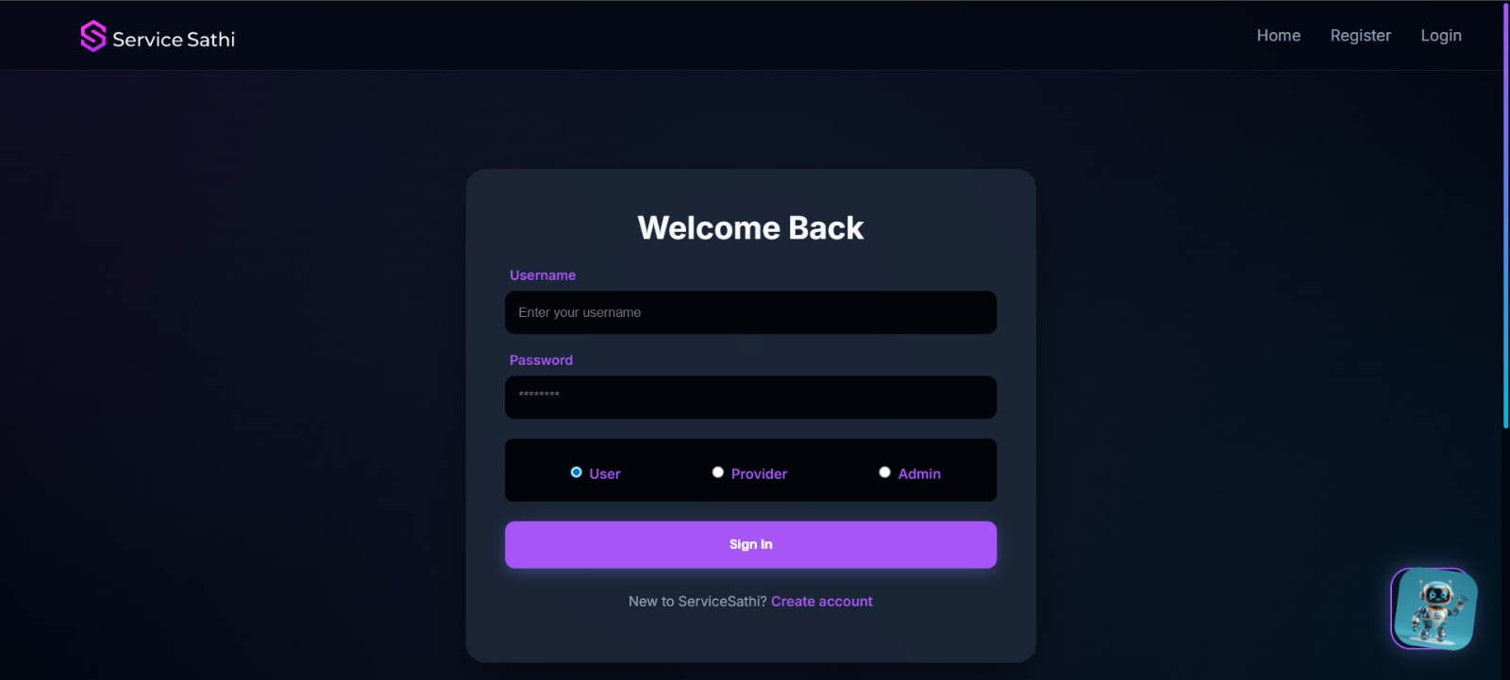
2.Dashboard
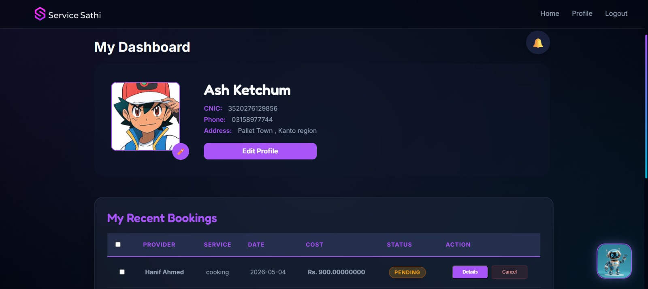
3.Book a service
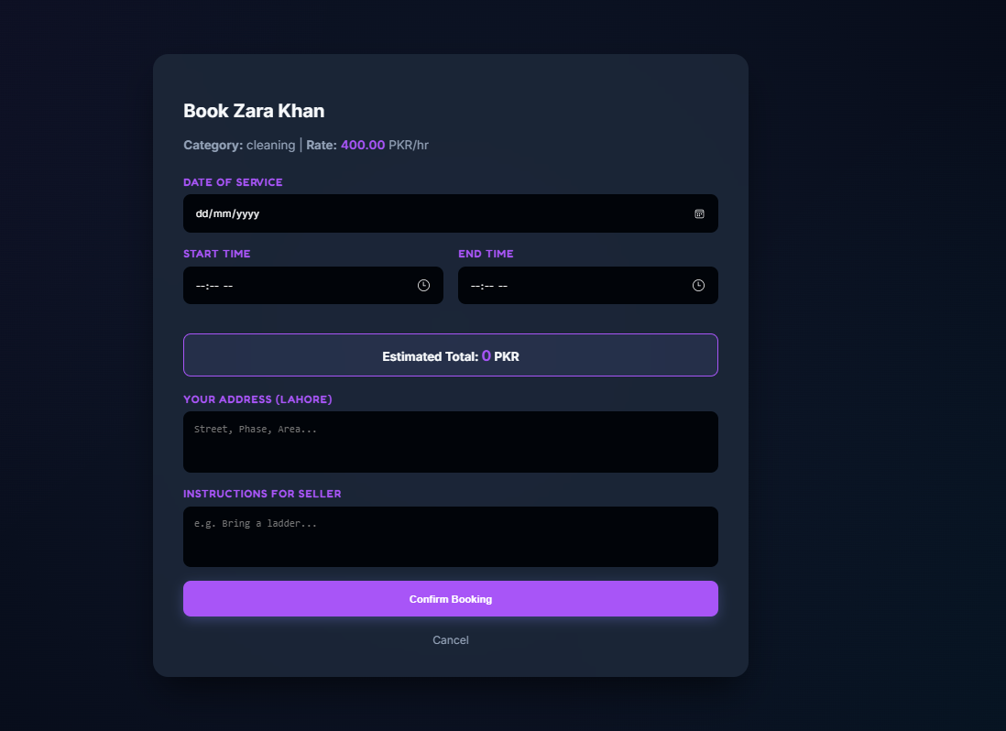
4.Edit Profile
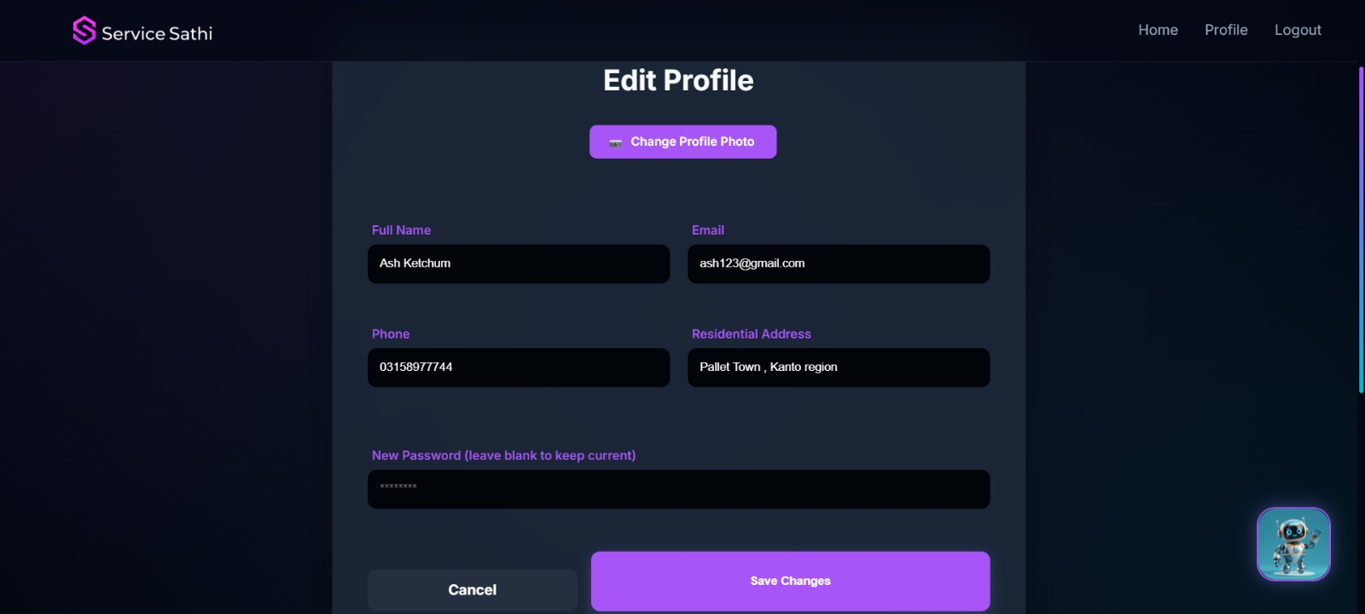
5.Sathibot
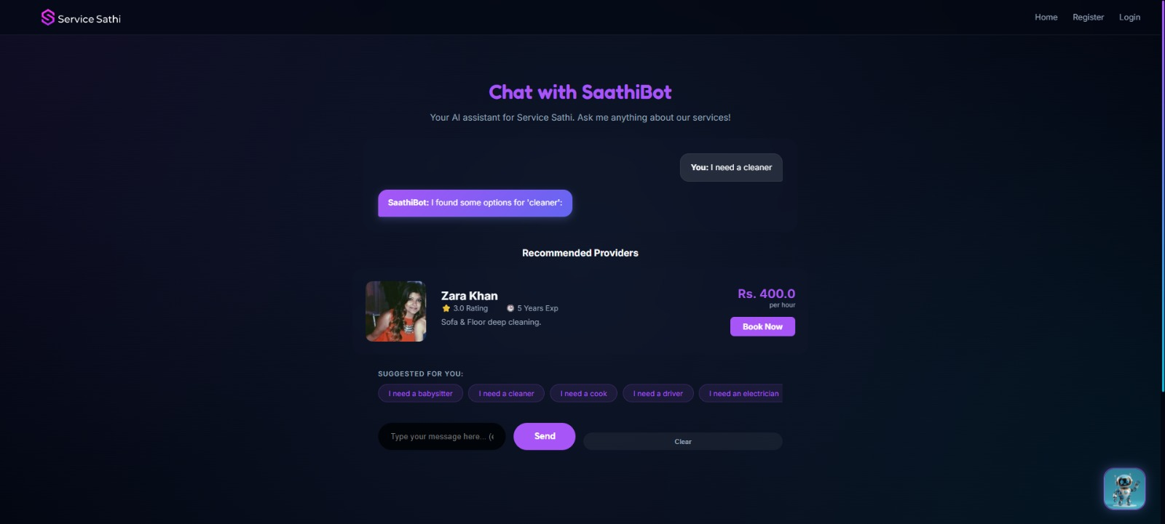
6.Add a Review
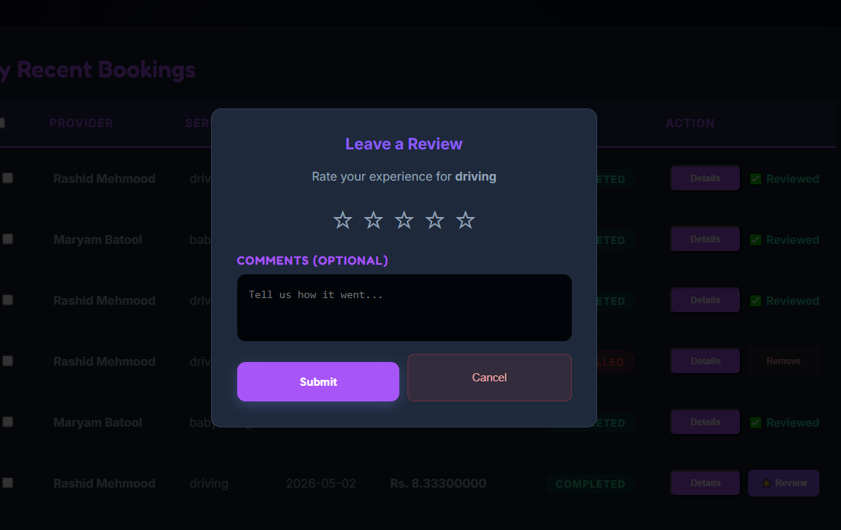
7.Notifications
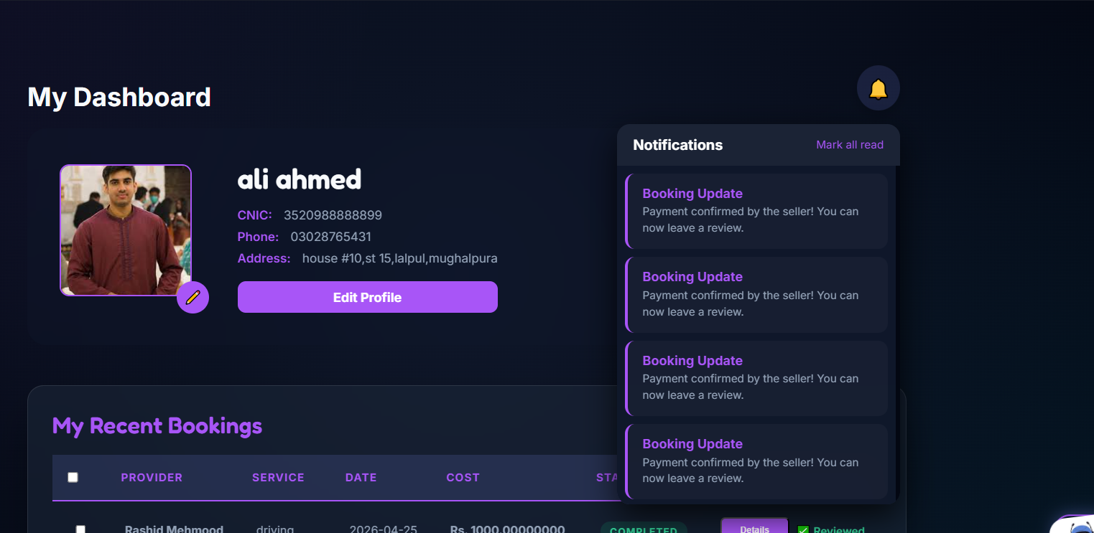

Work distribution

Team members | Tasks
Syeda Faryal Zehra | Frontend (HTML/CSS), Integration,Trello
Ibrahim Qaiser | Backend(Flask routes),  Booking Logic, Sathibot
Syeda Ume Abeeha Naqvi | Database, Documents, Testing, Diagrams

Leason Learnt

SQL Database Design: Structuring relational data for a real-world app
Responsive Design: Media queries and mobile-first thinking
Role-based Access: Managing different user types securely in one system
Team Collaboration: Dividing backend, frontend, and testing responsibilities effectively

